RCS Newsletter

User's Guide

Document Revisions
Date | Revision | By
December 15th, 2011 | 1 | Miguel Senosiain
December 29th, 2011 | 2.0 | Miguel Senosiain
January 24th, 2012 | 2.0.1 | Diego Verdecchia
April 13th, 2012 | 2.0.3 | Marcelo Aberastain

Table of Contents
RCS Newsletter 1
User's Guide 1
Document Revisions 2
General Description 4
Architecture 4
Installation 4
Setting up the portal to use RCS Newsletter 6
Changing the default database 6
Configuring Pages 8
Instantiating RCS Newsletter Portlets 8
Newsletter configuration 10
Lists tab 10
Adding a list. 10
Configuring the list’s subscribe, unsubscribe and greeting emails bodies. 11
Updating or Deleting a list. 13
Subscribers tab 13
Exporting subscribers 13
Importing subscribers 13
Templates tab 14
In this tab is where you manage the templates used to create a mailing. 14
Adding a template: 14
In the left panel choose Newsletter Administration and go to Templates tab. 14
Click on Add Template button. 14
Fill Name field with the name of the template you are creating, e.g. Common template. 14
Click on Help button, a list of tokens (and their description) that can be inserted in the email to be sent to the registered recipients, is shown. 14
Mailing tab 16
Adding Web Content to the Newsletter 16
Creating a mailing. 19
Sending the newsletter 19
Archive tab 20
Configure Newsletter Registration Portlet 21
Change Log 22

General Description
The aim of this project is to fulfill with all the features of a Newsletter, including mailing lists management, registration and un-registration system, confirmations, newsletter articles history and online newsletter visualization. powered by a group of fully configurable and scalable porlets that can be used in any Liferay portal.

Some of the main features are:
- Mailing list management
- Import/Export Subscribers
- Newsletter history
- On line newsletter viewer

Architecture

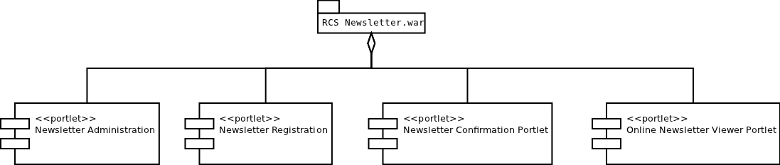Fig 1: Newsletter architecture
- Newsletter Administration:is a Control Panel portlet. You can’t decide where to instantiate it. It will be instantiated automatically into the Control Panel / <Your site> section. ie: Control Panel / Rotterdam CS
- Newsletter Registration: using this portlet, you will register for a newsletter, you may deploy it in wherever page you want.
- Newsletter Confirmation: this portlet MUST be deployed to the Home page of the portal. Its used to confirm that a user has been registered for the newsletter successfully.
- Online Newsletter Viewer: this portlet is used to read the subscribed newsletters in the portal page directly.

Installation
Firs things first. Deploy the RCS Newsletter into your portal. There are several ways to accomplish this. Here is one.
- Log in as an admin user and go to Control Panel.
- In the left panel, under Server category select Plugins Installation. Plugins Installation Page is shown.

- Select Portlet Plugins in the top of the page. Click on Install More Portlets button.

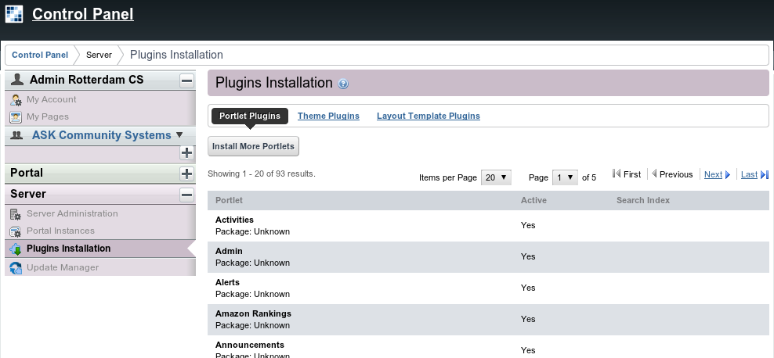Fig 2: Portlet Plugins list.

- Select Upload File in the top of the displayed page. Click on Choose File button, in order to get the file newsletter-portlet.war uploaded from your computer.

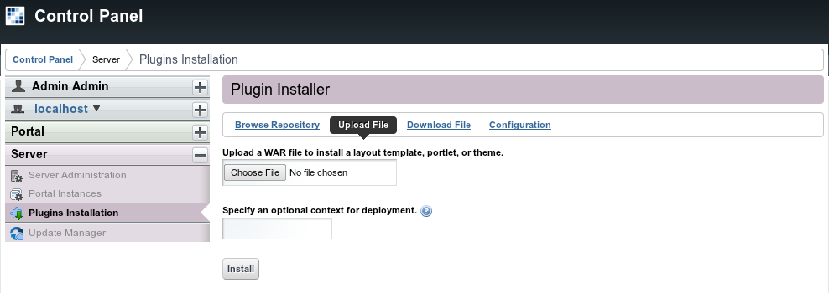Fig 3: Upload a new WAR file.
- Once the file is selected click on the Install button
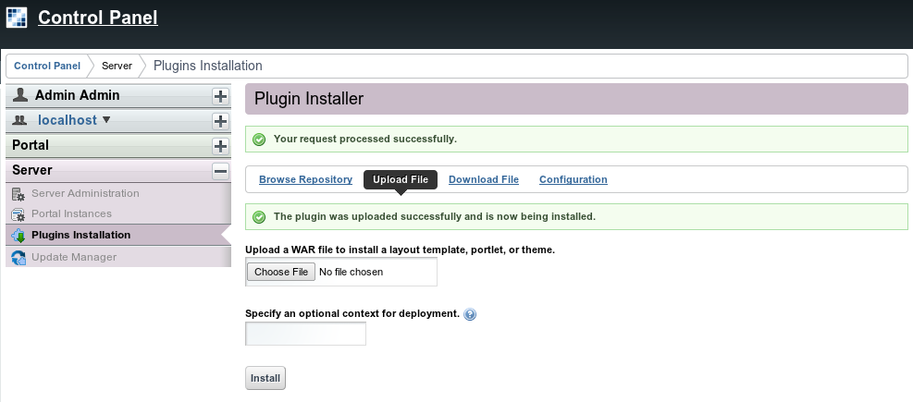Fig 4: WAR uploaded.

Once the newsletter is installed you can start configuring it.

Setting up the portal to use RCS Newsletter
In order to use RCS Newsletter, the following configuration must be set in portal-ext.properties file

journal.article.types=rcs-news,rcs-press-release,rcs-events,rcs-newsletter,rcs-general

Changing the default database
The RCS Newsletter is working with Postgres DBMS by default but is possible to work with another DBMS. One way to accomplish this is to download the RCS Newsletter portlet war file. The other one is to install it through Liferay control panel.

To do it with the war file, the following steps are required:

- Download RCS newsletter portlet war file.
- Open this file with some uncompress tool.
- Edit file liferay-persistence.xml at rcs-newsletter-portlet/WEB-INF/
- Replace this line:
<prop key="hibernate.dialect">org.hibernate.dialect.PostgreSQLDialect</prop>
for this one (e.g to work with MySQL):
<prop key="hibernate.dialect">org.hibernate.dialect.MySQLDialect</prop>

To do it trough control panel, the following steps are required:

- Install RCS Newsletter portlet.
- Shutdown tomcat instance
- Update file liferay-persistence.xml located at <liferay-installation-folder>/tomcat-6.0.x/webapps/rcs-newsletter-portlet/WEB-INF/
- Replace this line:
<prop key="hibernate.dialect">org.hibernate.dialect.PostgreSQLDialect</prop>
for this one (e.g to work with MySQL):
<prop key="hibernate.dialect">org.hibernate.dialect.MySQLDialect</prop>
- Start tomcat instance.

The link below contains a list of available dialects.
http://docs.jboss.org/hibernate/stable/annotations/api/org/hibernate/dialect/package-summary.html

Configuring Pages
- Log in as an admin user and go to Control Panel.
- In the left panel select Pages.
- In the name field you must enter “online-newsletter”. This is because the Online Newsletter Viewer needs to be instantiated in a page named like this.
- Select Hidden checkbox.
- Leave other values as default.
- Click on Add Page button.
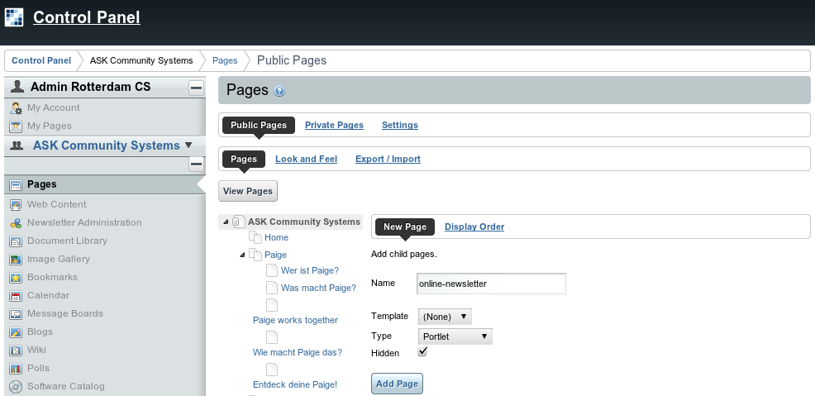Fig 5: Add online-newsletter.

Instantiating RCS Newsletter Portlets
The application’s portlets should be instantiated as described in the diagram below.
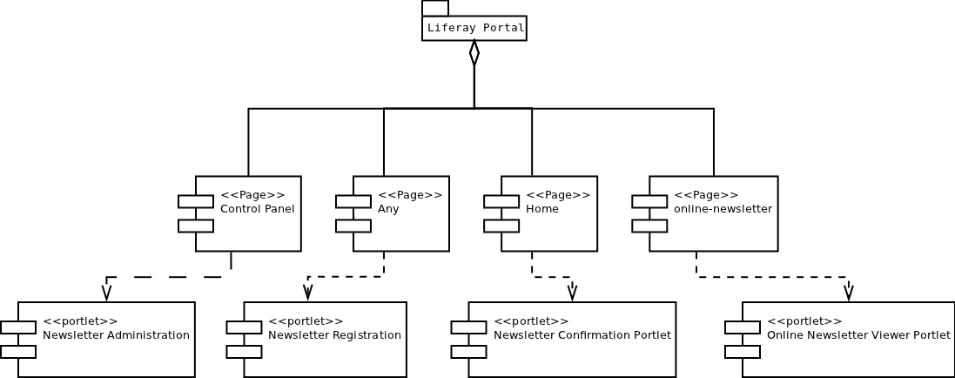Fig 6: RCS Newsletter portlets, as they should be instantiated.
- Log in as an admin user.
- On the top menu bar select Add. Click on More...
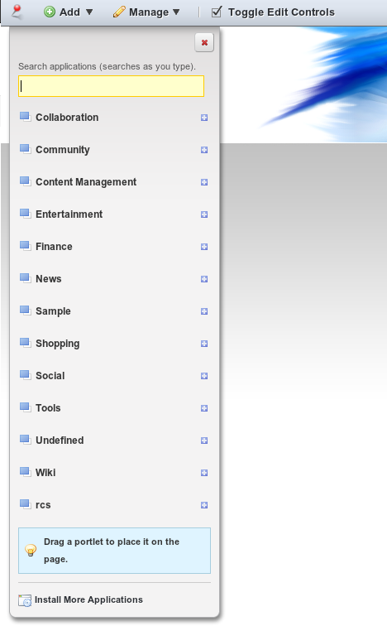Fig 7: Portlet Plugins list.

- Expand the rcs category.
- To instantiate a portlet, just drag and drop it from the list into the page you want it to be displayed.
- On the portal’s home page you must instantiate “Newsletter Confirmation Portlet”. This portlet default state is hidden so you won’t see any changes in the home page.
- Instantiate Newsletter Registration Portlet in any page of the portal, or create one for it.
- Instantiate Online Newsletter Viewer Portlet in the page created earlier for it (online-newsletter).

Newsletter configuration
The Newsletter Administration section has four tabs: Lists, Subscribers, Mailing and Archive. Each one of this tabs, is used to configure different aspects of the RCS Newsletter.
To access the Newsletter Administration page follow the steps described below.
- Log in as an admin user and go to Control Panel.
- Select Newsletter Administration in the left panel.
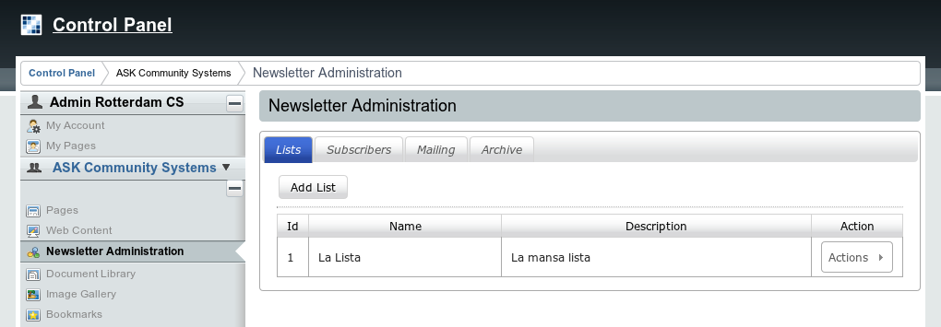Fig 8: Newsletter Administration.

Lists tab
The Lists tab is used to create, update and remove the mailing lists for which newsletters will be sent.

Adding a list.
- Click on Add List.
- Enter a name for the list, its description the name that will be sending the newsletter and the email address used for sending the newsletter. When done, click Save button. You can create many list as you want.
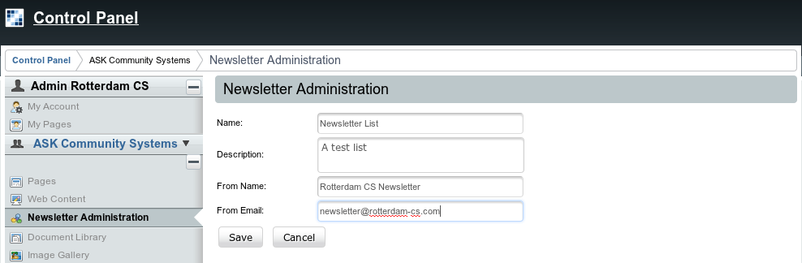Fig 9: List creation.

Configuring the list’s subscribe, unsubscribe and greeting emails bodies.
- In the list you wish to configure, click on Actions button and select the menu item for the email type you want to configure.

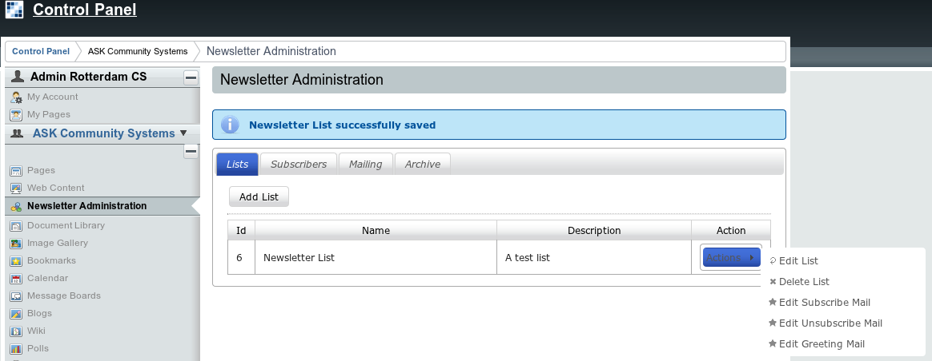Fig 10: List Actions.

- Configure the list to have the three required emails: Greeting, Subscribe, Unsubscribe. If you click on Help button, a list of tokens (and their description) that should be inserted in the email to be sent to the registered recipients, is shown.
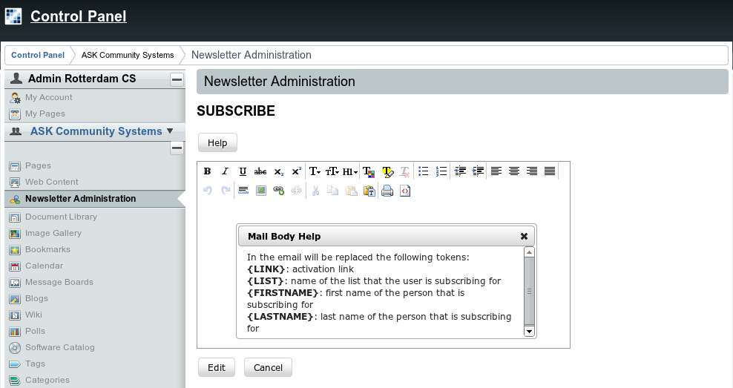Fig 11: Email edition help window.

- Edit the email body using the tools in the editor window.
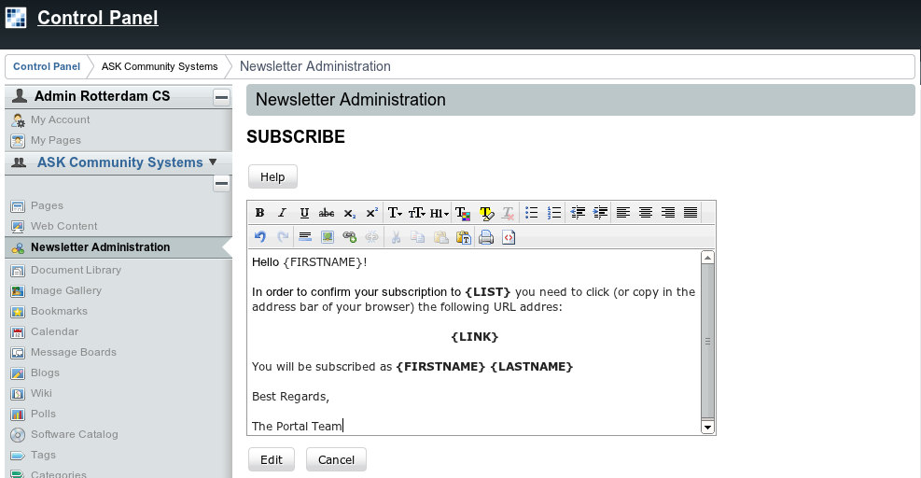Fig 12: Subscribe email message creation.

Note: Remember to include the token {LINK}, so the user can confirm his registration.

- Repeat steps 5, 6 and 7 in order to create the email messages for Greeting and Unsubscribe actions. Remember that the Help button displays the tokens that should be included in the email message body.

Updating or Deleting a list.
- In the list you wish to update or delete, click on Actions button and select the appropriate menu item for the action you are trying to perform.

Subscribers tab
In this tab you’ll see the subscribers of each list displayed in a grid. Also, you can choose either to display or not, the inactive subscribers of each list.
Also in this tab you can import or export subscribers into/from a list.

Exporting subscribers
- In the Subscribers tab click on Export subscribers to excel button. An Excel file is downloaded, with the following columns:
- id: the internal ID of the subscriber.
- Name: subscriber’s name.
- Last Name: subscriber’s last name.
- Email: subscriber’s registered email address.

Importing subscribers
The Excel file to be imported, must have the following columns:
- Name: subscriber’s name.
- Last Name: subscriber’s last name.
- Email: subscriber’s registered email address.

- In the Subscribers tab, click on Import Subscribers button.
- Choose a List, onto which the subscribers will be imported, or all list.
- Click choose file, and browse for the Excel file containing the subscribers data.
- Click Import button.

Note: Instead of creating a new Excel file, you can use a downloaded earlier with up to date data. (The value of the id column isn’t necessary and its recommended to leave it blank)

Templates tab

In this tab is where you manage the templates used to create a mailing.
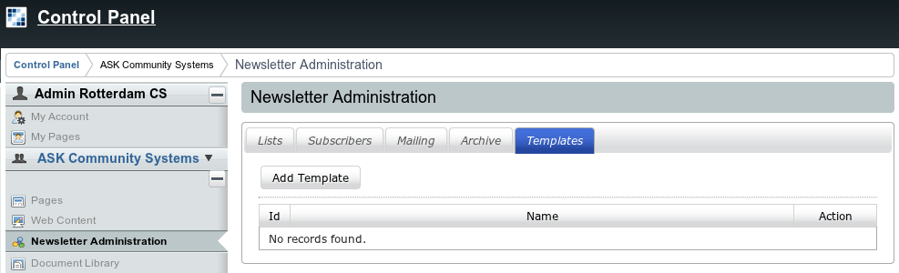Fig 13: Templates tab.

Adding a template:
- Log in as an admin user and go to the Control Panel.

In the left panel choose Newsletter Administration and go to Templates tab.

Click on Add Template button.

Fill Name field with the name of the template you are creating, e.g. Common template.

Click on Help button, a list of tokens (and their description) that can be inserted in the email to be sent to the registered recipients, is shown.
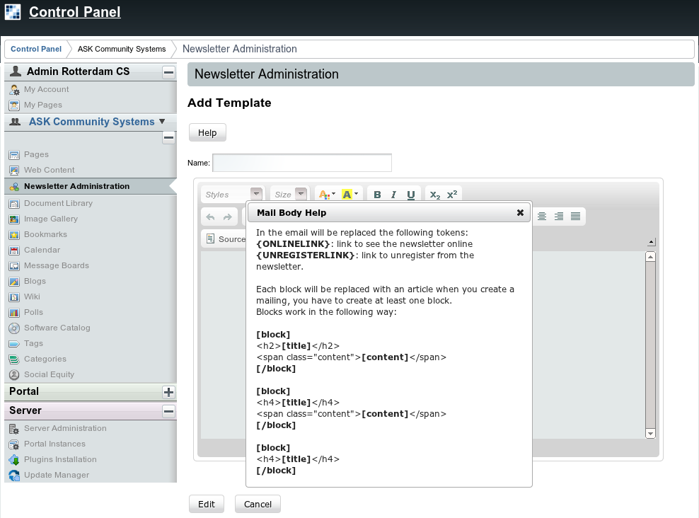Fig 14: Templates Help window
- Copy one of the [block] [/block] sections and paste it on the editor. Each block will be replaced with an article when you create a mailing, you have to create at least one block.
- Remove the format of the pasted block. Select it and click on the Remove Format button in the editor's toolbar.
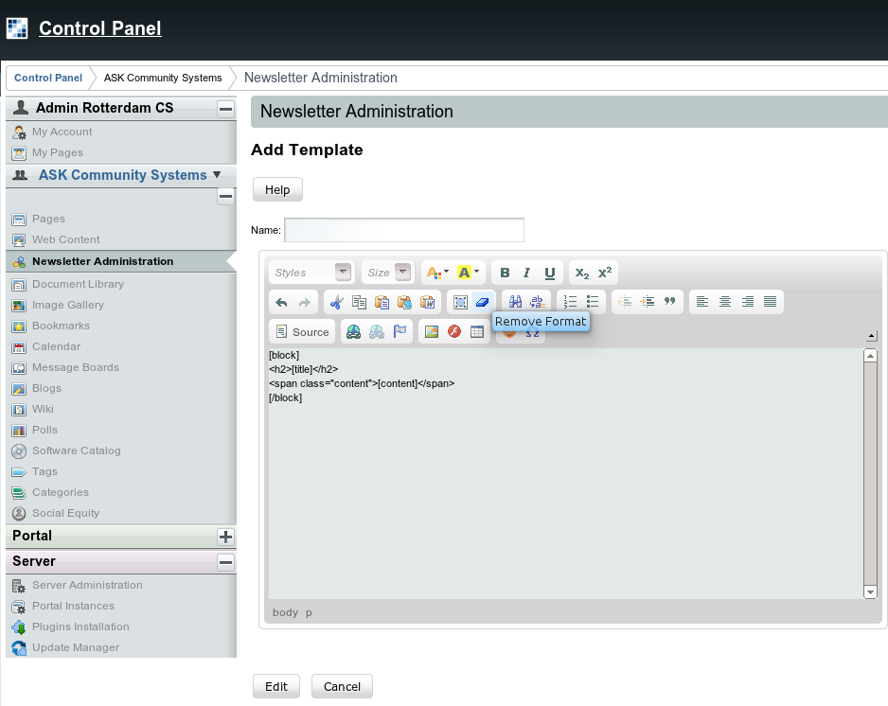Fig 15: Remove format

Mailing tab
In this tab is where you select the content and send a newsletter.

Adding Web Content to the Newsletter
Once you have configured your portal the steps to add a web content to be used in a mailing are as follow:

- Log in as an admin user and go to the Control Panel.
- In the left panel select Web Content.
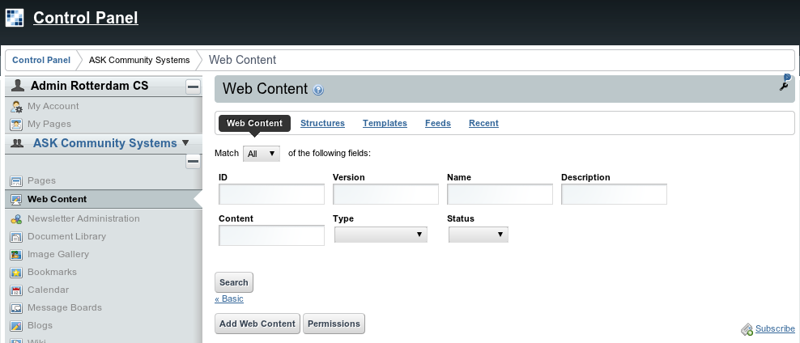Fig 16: Web Content Main form.

- Click on Add Web Content button.
- Fill Name field with the name you want to give to the web content that will be used in the newsletter mailing.
- Edit the web content using the editor.
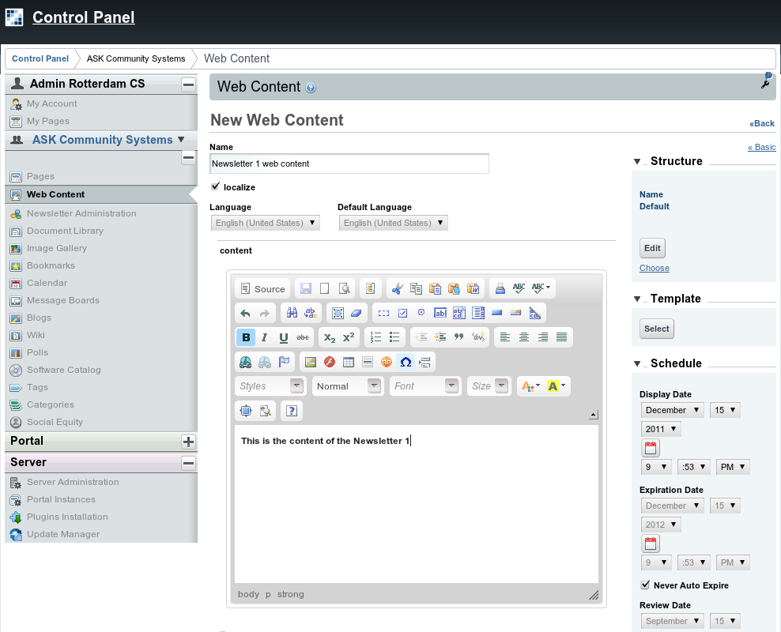Fig 17: Adding Web Content.

- In Categorization section choose at least one of the following methods.
- Type: choose rcs-newsletter
- Categories: You'll need to create a category in Control Panel > Categories, name it newsletter.
- Tags: Just type newsletter.
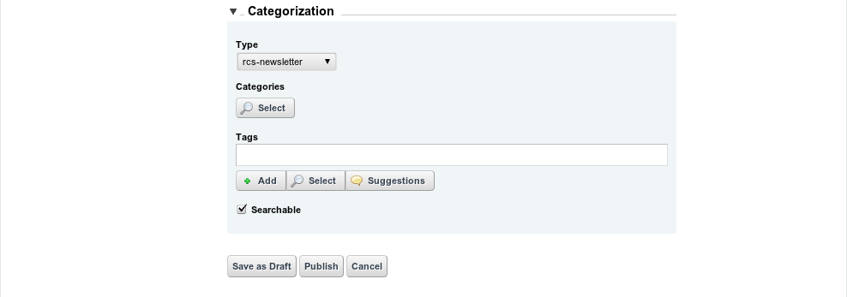Fig 18: Web Content Editor - Categorization Section.

- Click on Publish button.

Creating a mailing.
- Log in as an admin user and go to the Control Panel.
- In the left panel choose Newsletter Administration and go to Mailing tab.
- Click on Add Mailing button.
- Type the name of the mailing to be sent in the Name field.
- Choose the list where the mailing will be sent from the List dropdown.
- From the Template dropdown, choose a previously created template.
- Select an article for each block added to the selected template.
- Click on Add Mailing button.
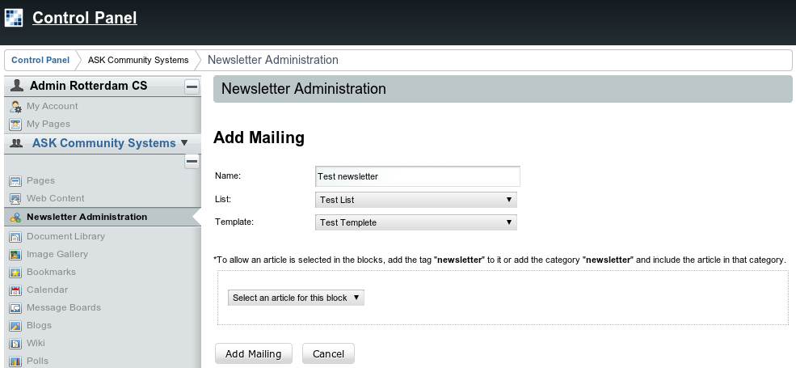Fig 19: Add Mailing.

Sending the newsletter
- Select the radio button for the mailing you want to send and click on Send Newsletter button. Optionally you can fill a test email address and click on Send Test button, in order to see how the email is displayed.
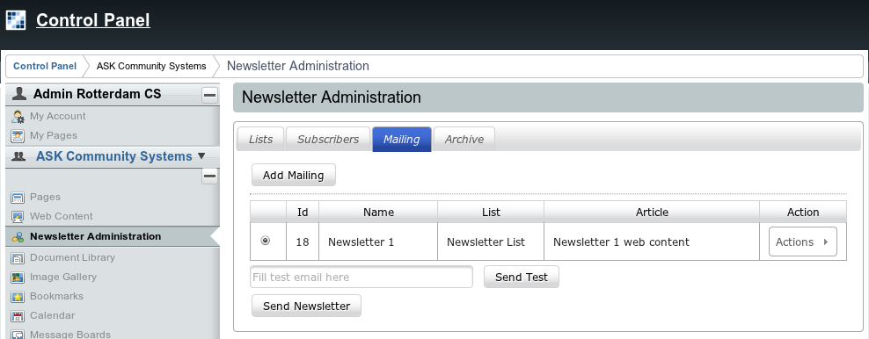Fig 20: Send Newsletter.

- In the Send Newsletter confirmation window, review the data shown and if you agree with it, tick I understand the risks involved in this action checkbox and click on Send Newsletter button. Otherwise click on No, please take me back button.
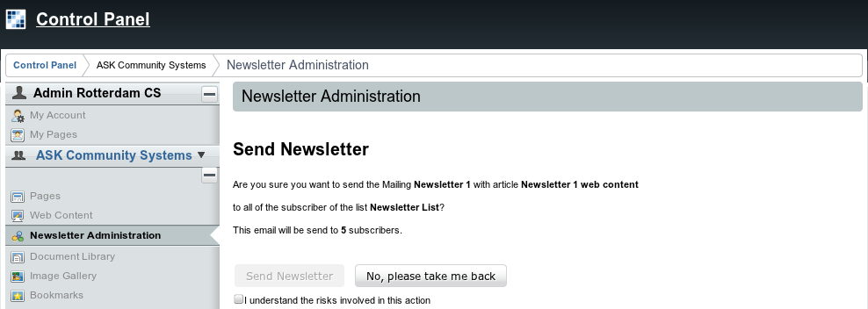Fig 21: Newsletter confirmation.

- The newsletter is svheduled to be sent and its moved from Mailing tab grid to Archive tab grid.

Archive tab
In this tab is where the newsletters sent previously are stored.
It contains a grid with the following structure:
- Id: Is the internal ID of the newsletter.
- Name: Contains the name of the archived newsletter.
- List: The list to which the newsletter was sent.
- Date: The date where the newsletter was sent.
- Action: A menu from where you can choose to see what was sent in the newsletter.

Configure Newsletter Registration Portlet
Let’s suppose that you want to have two different news letters in your site, one about wines and another about food.
RCS Newsletter allow your users to register in any amount of newsletters you define in your site.
In order to accomplish this you need to have as many Newsletter Registration Portlet instances (each one associated to a list) as newsletters you wish to have.
- Log in as an admin user and go to the page that host the instance you want to configure.
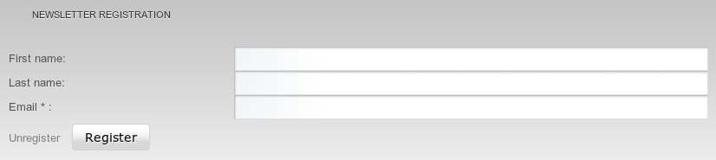Fig 22: Newsletter Registration Portlet.

- Click on the wrench tool icon, a menu will expand, select Preferences.
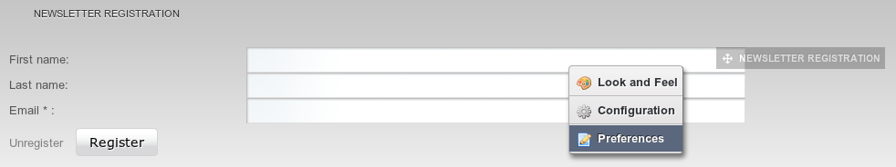Fig 23: Preferences menu of Newsletter Registration Portlet.

- In the Newsletter Registration Settings, select the list to associate to the portlet from the List dropdown. Optionally, you can choose not to require the Name and Last Name of the user by ticking Disabled Name fields checkbox. When done click Save Settings button.
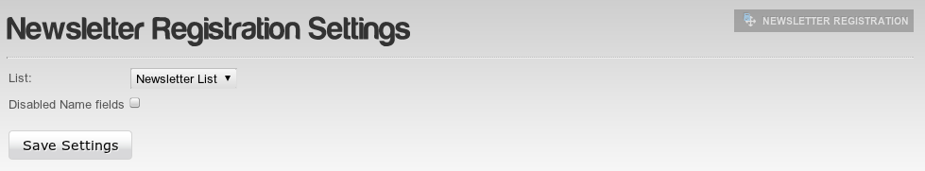

- In order to return to the normal view just click back in Preferences in the wrench tool icon, like in step 2.

Change Log

Changes applied in version 2.0.3:

1 - Send journal articles based on a templates Fixed

2 - Dutch translation completed

3 - Unnecessary warn message removed

4 - Bug in portletfaces bridge 2.0.1 Fixed : Multiple organization problem

5 -Help template in NL fixed

6 -Add/edit template title fixed

The portal-ext.properties file should be located at <LIFERAY_HOME>/Liferay-portal-X.X.X/portal-ext.properties

